This software failure that happened on 11 December 2000 caused a control error in a Boeing V-22 Osprey aircraft that crashed near Jacksonville.

This aircraft is both an airplane and a helicopter, and it was undirectly the cause of the crash.

The crash happened because the plane suffered a hydraulic system fault: a vibration-induced chafing from an adjacent wiring bundle lead to a leak which fed the primary side of the swashplate actuators to the right side rotor blade controls, leading to a hydraulic line broke in one of the two engine cases as the aircraft was shifting from airplane to helicopter mode for landing.

This happened because the flight-control computer software stopped the rotation of the engine pods when it detected a Primary Flight Control System (PFCS) alert: the hydraulic failure.

While the failure was happening, the pilots tried to reset the software as the result of the PFCS alert but without success.

This failure caused the crash of the plane and consequently the loss of four lives.

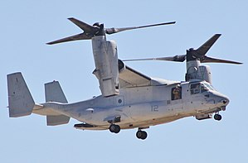

Sources:

<https://www.computerworld.com/article/2515483/enterprise-applications/epic-failures--11-infamous-software-bugs.html?page=6>

<https://en.wikipedia.org/wiki/Accidents_and_incidents_involving_the_V-22_Osprey>

<http://edition.cnn.com/2000/US/12/12/osprey.crash/>